April 3rd, 2019

TALKBOX USER MANUAL

Group 15

EECS2311, York University

Table of Contents

1 Introduction…………………………………………………………..….…3

2 How to Get Started………………………………………….……………..3

System Requirements………………………………………….……….3

Installation Instructions……………………………………….………..3

3 How to Use……………………………………………………….………..4

Sim Preview Panel…………………………………………….……….5

Recording and Editing Panel……………………………………..……5

Playback Mode…...……………………………………………………6

Edit Mode……………...………………………………………………7

Updating Number of Buttons……………………………………7

Updating Button Labels…………………………………………7  
Updating Button Icons…………………………………………..8

Recording Audio ……………………………………….……….8  
Updating Button Audio………………………………………….8  
Saving and Launching the Simulator…………………...……….8

Profiles Panel ………….………………………………………………9

4 Common Profile Uses……………………………………………….……10

1 Introduction

The TalkBox device is designed to be a communication and speech aide for users with verbal impairments, and is designed to be fully configurable based on user needs. Functions such as the number of buttons on the device, and the audio files loaded onto it can be personalized through the TalkBox Configuration App. The following instructions detail the setup, configuration, and use of the TalkBox device and Configuration App.

2 How to Get Started

System Requirements

To use TalkBox, your system must have the Java Runtime Environment installed. If you do not already have it installed, follow the link to download it.

[> Click to download Java Runtime Environment](https://www.java.com/en/download/)

Installation Instructions

To use TalkBox, first download “TalkBox.jar” onto your system. Save the program to the desired location of your device. To launch the program, double click on the “TalkBox.jar” icon.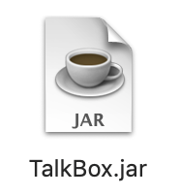

Figure 1: TalkBox program icon

3 How to Use

When the TalkBox program is launched, a pop-up file dialogue will appear. Using the file selector, choose a directory to save or load TalkBox data. A folder called TalkBoxData will be created in your selected directory. TalkBoxData will hold files used in the TalkBox device, for example audio files that are associated with TalkBox buttons.

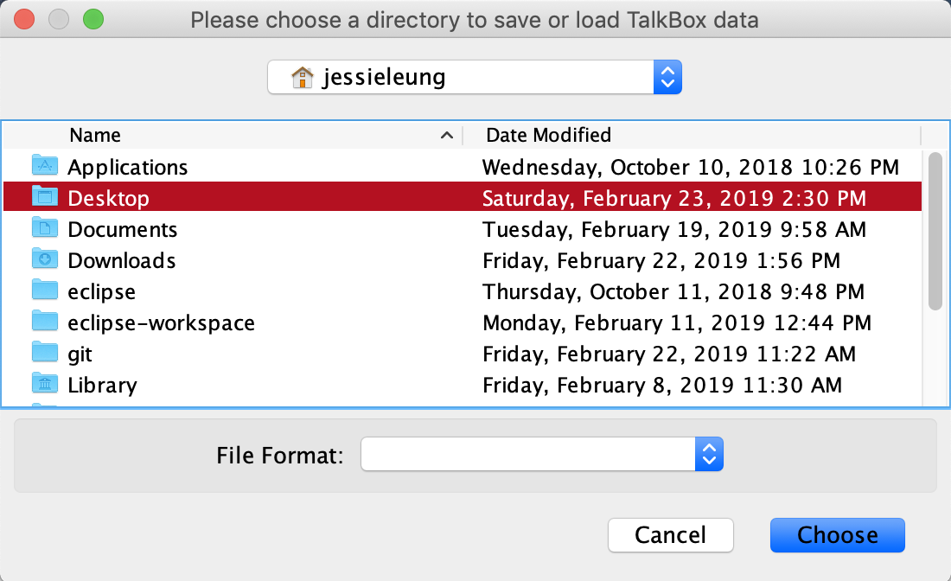

Figure 2: TalkBoxData directory chooser

After you have selected the TalkBoxData directory using the file chooser, the TalkBox Configuration App will launch.

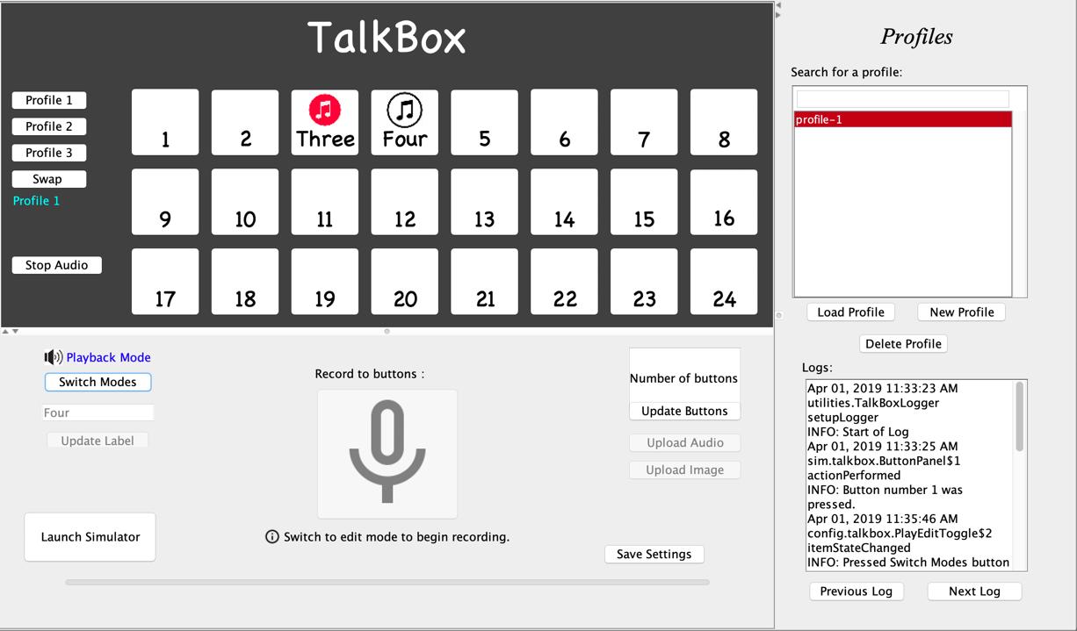

Figure 3: TalkBox Configuration App

Sim Preview Panel

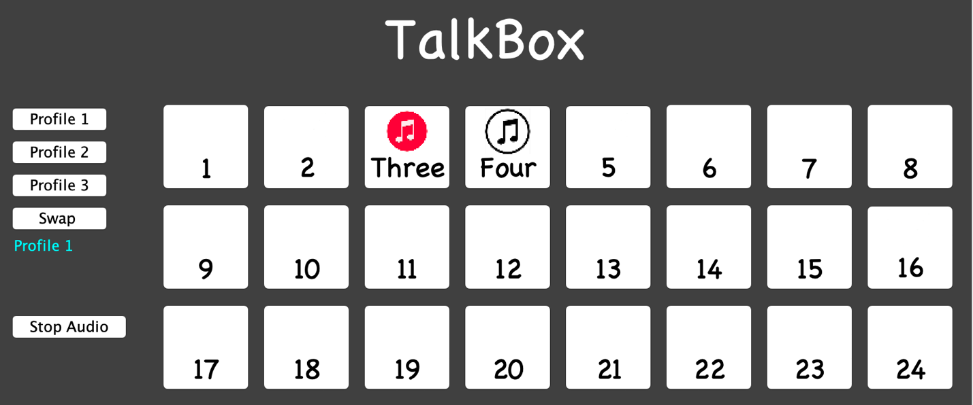

Figure 4: Sim Preview Panel

The Sim Preview Panel in the top left corner of the TalkBox Configuration App displays the state of the TalkBox device as it will be when launched. The profile switching buttons on the left of the panel are used to swap between audio sets. The buttons on the main face of the panel are the audio playback buttons used in the TalkBox device. The set up of these buttons will be explained in the following section.

Recording and Editing Panel

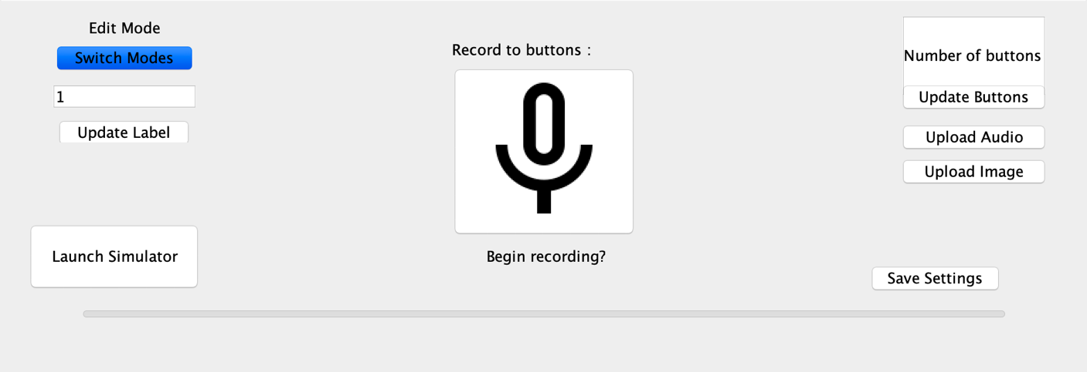

Figure 5: Recording and Editing Panel

The Recording and Editing Panel can be found in the lower panel of the TalkBox Configuration App. This panel is used to adjust the functions and composition of the TalkBox device. Changes made in the Recording and Editing panel will display real-time in the Sim Preview panel, and will be the same as the state of the TalkBox device when it is launched.

The recording and editing panel has a “Switch Modes” toggle button that allows you to switch between Playback and Edit Modes. Clicking the toggle button will switch between the two modes, and the current mode is displayed in text above the toggle button (highlighted in red in Figure 6).

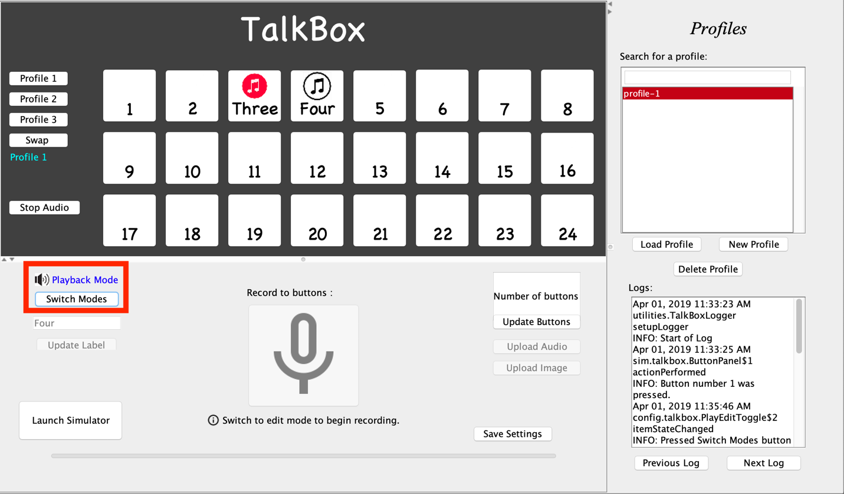

Figure 6: Playback/Edit Mode Toggle Button

Playback Mode

When the TalkBox Configuration App is in playback mode, the purpose is to simulate the behaviour of the TalkBox device when it is launched. In playback mode, features such as recording and updating button labels is disabled. Clicking on the buttons in the Sim Preview panel will allow the Sim Preview panel to perform exactly as the actual TalkBox device would. Clicking on the audio buttons will trigger playback if there is audio associated with the buttons, and clicking the profile swap buttons will switch the button associations between audio sets.

Edit Mode

In edit mode, features of the Record and Edit Panel (such as the record button and button labelling function) become enabled so that you can adjust the configuration of the TalkBox device.

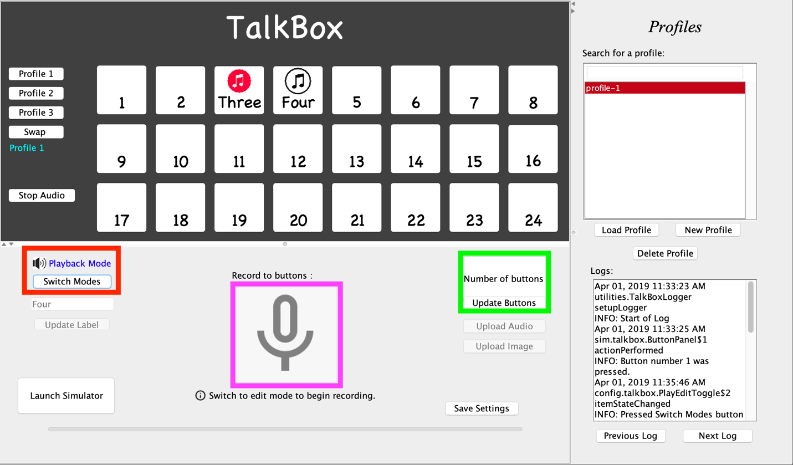

Figure 7: Edit Mode

Updating Number of Buttons

To change the number of buttons in the TalkBox device, edit the button number textfield (highlighted in green in Figure 7) in the Record and Edit Panel, then either hit “Enter” on your keyboard or click the “Update Buttons” button. The Sim Preview panel will then update to display the correct number of buttons.

Updating Button Labels

To update the button labels, click on the desired button on the Sim Preview panel. The selected button will become highlighted by blue text, and the button’s current button label will be displayed in the button label textfield (highlighted in red in Figure 7). Input your desired button label by typing into the button label textfield, then hit “Enter” on your keyboard or click the “Update Label” button. The button label will now appear on the selected button in the Sim Preview panel.

Updating Button Icons

To add button icons, click on the desired button on the Sim Preview panel. The selected button will be highlighted by blue text. To upload an icon to the button, you can click the “Uplolad Image” button and select an icon from the File Chooser, and it will be uploaded to the selected button. Or, you can drag and drop an image from your device’s system and drop it directly on the desired button on the Sim Preview panel, and it will be uploaded directly to the button.

Recording Audio

To record audio to a selected button, first select a button in the Sim Preview panel. Once you have selected the desired button and are ready to record audio, click the “Record” button (indicated with the microphone icon and highlighted in pink in Figure 7). If a mic is detected on your system, recording will then begin. Speak clearly into your mic, and click the “Stop Recording” button. The audio recorded will now be associated with the selected button, you may re-click the selected button to hear playback of the recorded audio.

Mic not detected error — If there is no mic detected on your system, recording will not begin, and a text indicator will indicate the error. In this case, please check that your system’s built-in microphone is enabled or that an external microphone is plugged into your system.

Updating Button Audio

Once you have recorded audio files, you can associate them with buttons on the Sim Preview by using the “Upload Audio” button on the Recording and Editing panel. In Edit Mode, click on the button that you wish to update, click the “Upload Audio” button and select the desired audio file from the File Chooser popup. You can also use drag and drop functionality with the audio files by dragging an audio file from your device system and dropping it onto the button that you wish to update. The audio file now be uploaded to the desired button.

Saving and Launching the Simulator

Once you have the TalkBox Config App configured as you want, click the “Save Settings” button at the bottom right corner of the Recording and Editing panel. This will save the state of the Config App so that upon your next launch, this state will be displayed.

To launch the TalkBox Sim App, click the “Launch Simulator” button at the bottom left corner of the Recording and Editing panel. A warning popup will open asking if all changes to the Config App have been saved. If yes, click the “Launch Simulator” button, and the TalkBox Sim App will launch.

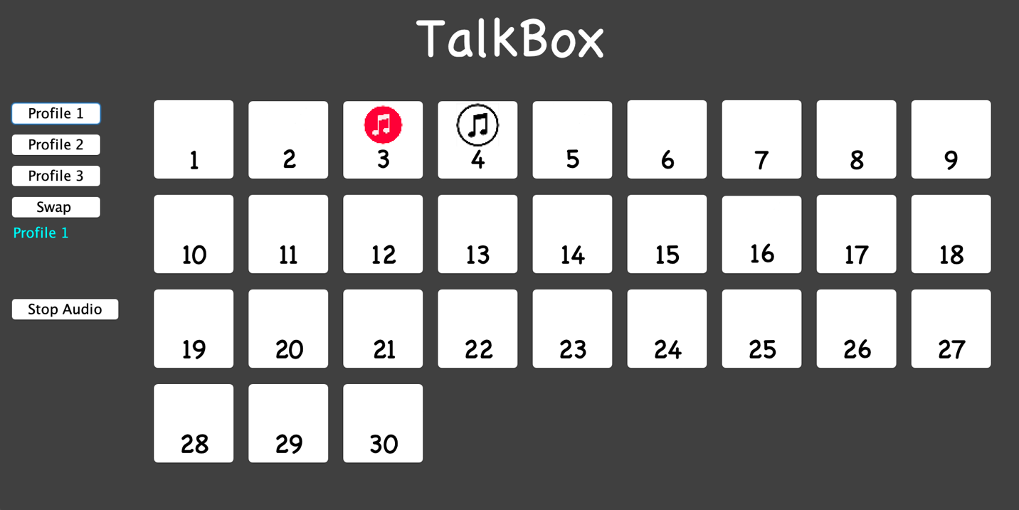

Figure 8: TalkBox Sim App

Profiles Panel

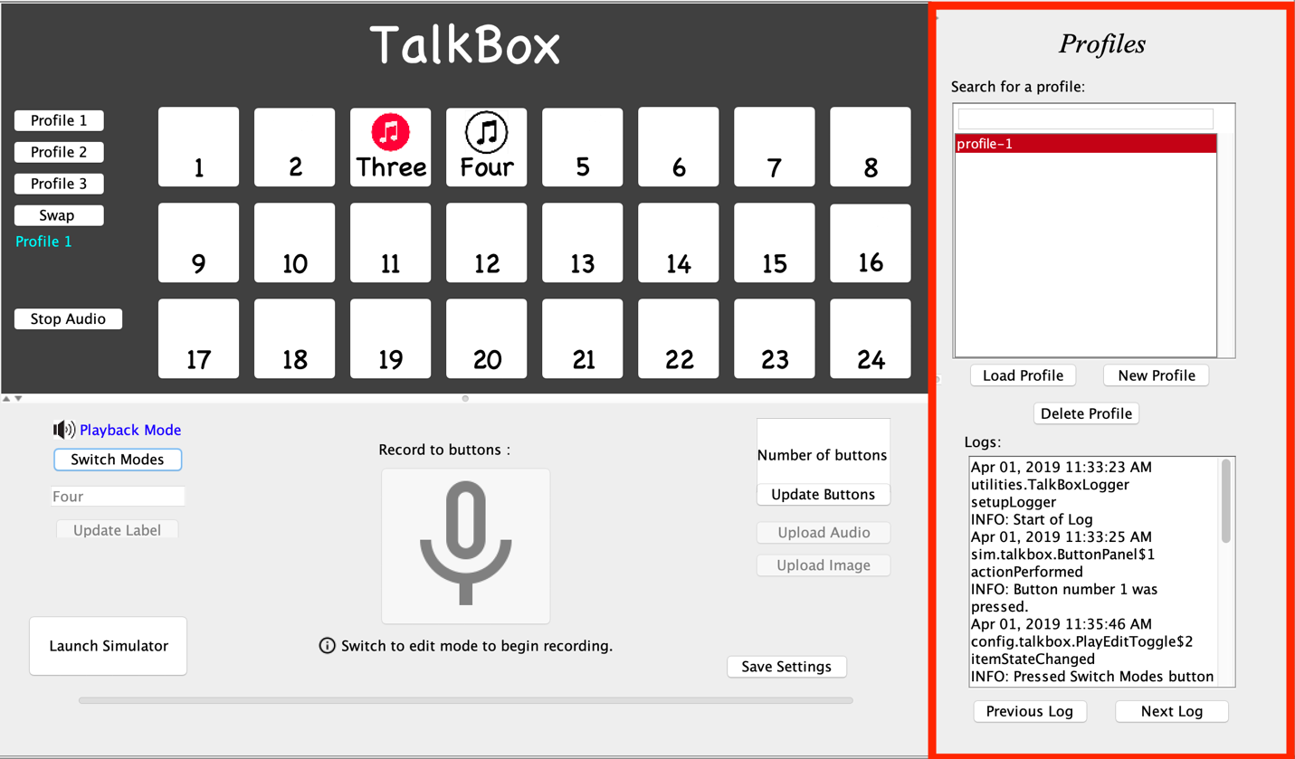

Figure 9: Profiles Panel

The Profiles panel (highlighted with red in Figure 8), is used to load, create, and delete profiles that can be launched in the TalkBox device. Using the selector, you may choose from the saved profiles. You can load a profile onto the Sim Preview panel using the “Load Profile” button. When a profile is loaded, a saved set of audio files, button labels and button icons are loaded onto the buttons of the Sim Preview panel. New profiles can be created and deleted based on your desired configurations for the TalkBox device.

At the bottom of the Profiles Panel, a Logger displays actions and changes made to the TalkBox Config App.

4 Common Profile Uses

The profiles loaded onto the TalkBox device can be selected and personalized based on user needs. Some common use scenarios in which users may find the TalkBox deice most useful are as follows. These common use scenarios are audio profiles (audio files associated to buttons on the TalkBox device) that can be pre-loaded onto the TalkBox device.

1. General purpose education: Yes, No, I understand, I don’t understand, Can you explain more?, I would like assistance
2. Emotions: Happy, Sad, Excited, Confused, Anxious, Bored
3. Weather: Sunny, Rainy, Cloudy, Snowy, Icy, Hot, Warm, Chilly, Cold, Freezing, Windy
4. Hospital: Yes, No, I am in pain, I am okay, Help!
5. Restaurant: Menu, Water, Restroom, I would like to order something, Thank you, May I have the bill?